**README FOR THE CREATIVESDKSAMPLEAPP -**

The CreativeSDKSampleApp is a simple test sample created to demonstrate how to use the Android CreativeSDKFoundation for developing apps. The current application makes use of only the public API exposed by the AndroidCreativeSDK.

You can refer to the API documentation to know the list of APIs which the Android CreativeSDKFoundation provides.

This app has a main activity with 2 buttons, one for the viewing the assets in your creative cloud account and the second one for publishing to Behance.

While viewing the files after launching the asset browser component provided by the Android CreativeSDK , you could also muti-select testfiles and click on the open button. This would create a collage of our the files selected. Further from the collage view you could also individually select files and view it in fullscreen mode.

Note : The collage will show up the files for which the rendition data is available with us. In case , you choose say a fla(which doesn’t have the rendition data) , we do not show up anything. However, this logic could be handled in the source code of the sample application.

Hope this test app serves as a quick reference guide and helps you in creating apps using the AndroidCreativeSDK.

**STEPS FOR SETTING UP THE TESTAPPLICATION -**

01)Refer to the getting started document and get a client ID and client secret for using the CreativeSDKSampleApp.

02)Import the CreativeSDKSampleApp project to your eclipse workspace.

03)Import the dependent projects which are added as part of the CreativeSDKSampleApp/deps folder namely the CreativeSDKFoundation and the CreativeSDKBehance projects.

04)Check the dependencies for the CreativeSDKSampleApp opening the Project->Projecties dialog and selecting Android from the left panel. By default the 2 projects should be added as shown in the screenshot below :

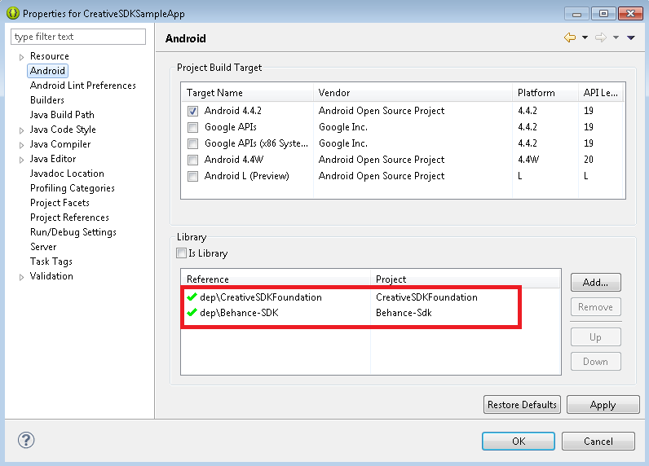

05)Build the CreativeSDKSampleApp project and run to launch this android test app.